**ASHWINI PRATAP SINGH**



**PERSONAL DETAILS:**

* Class: II
* Gender: Male
* School: Gayatri Shiksha Niketan,

Adityapur

* Board of School: CBSE
* Medium of instruction: English

**DETAILS ABOUT FAMILY:**

* Father’s name: Mrityunjay Pratap Singh
* Mother’s name: Vijaymala Devi
* No of members in family: Five, one sister, one brother, mother and father
* Profession of father: Unemployed
* Profession of mother: Housewife

**FINANCIAL OVERVIEW:**

Monthly net income of household: NIL/-

**Total annual expenditure on education: Rs. 11,300/-**

Breakup of expenses

Tuition fees: Rs 500/- (per month) = Rs. 6000/- (per year)

Admission fees: Rs. 2000/- (per year)

Stationery: Rs. 3300/- (per year)

**Average monthly expenditure on education: Rs. 950/-**

**ENCLOSURES:**

1)Report Card of Class I (Previous class attended)

Report Card Page-1

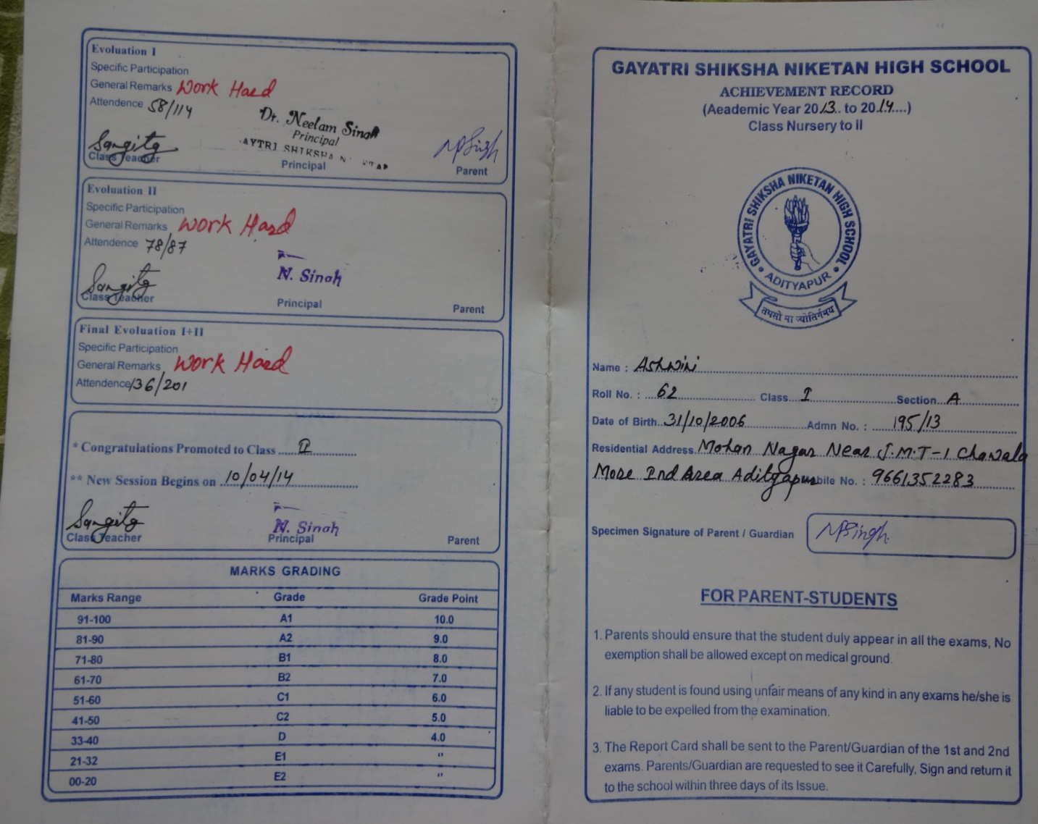

Report Card Page -2

